R PROGRAMMING

EXPERIMENT-6
MEAN,MEDIAN,MODE:
AIM:
To write the program for mean,median, mode.
PROGRAM:
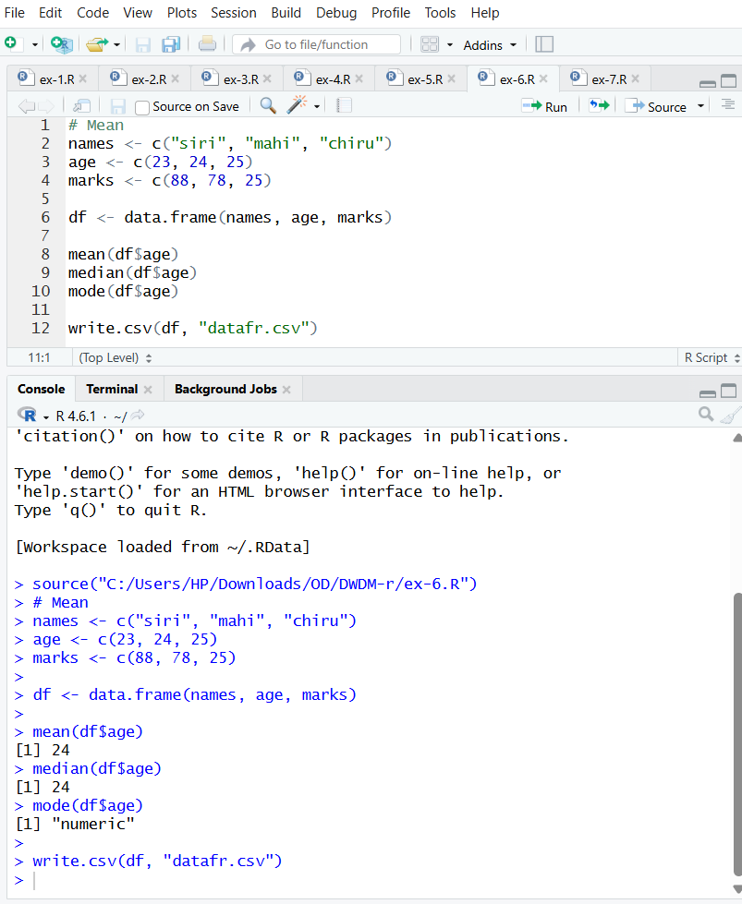
RESULT:
Thus the central tendency and measure of dispersion is executed successfully.

EXPERIMENT-7
SUMMARY:
AIM:
To write the program for summary using R-tool.
PROGRAM:
OUTPUT:
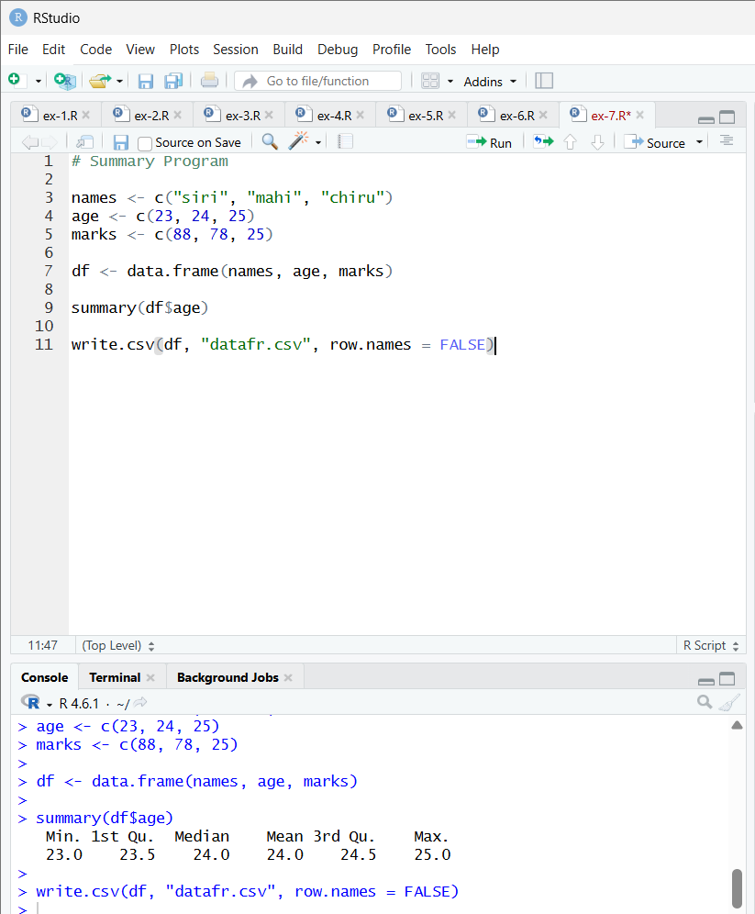
RESULT:
Thus, the central tendancy and measure of dispersion is executed successfully.

EXPERIMENT-8
GREATER AMONG THREE NUMBERS:
AIM:
To write the program for the greatest among three numbers.
PROGRAM:
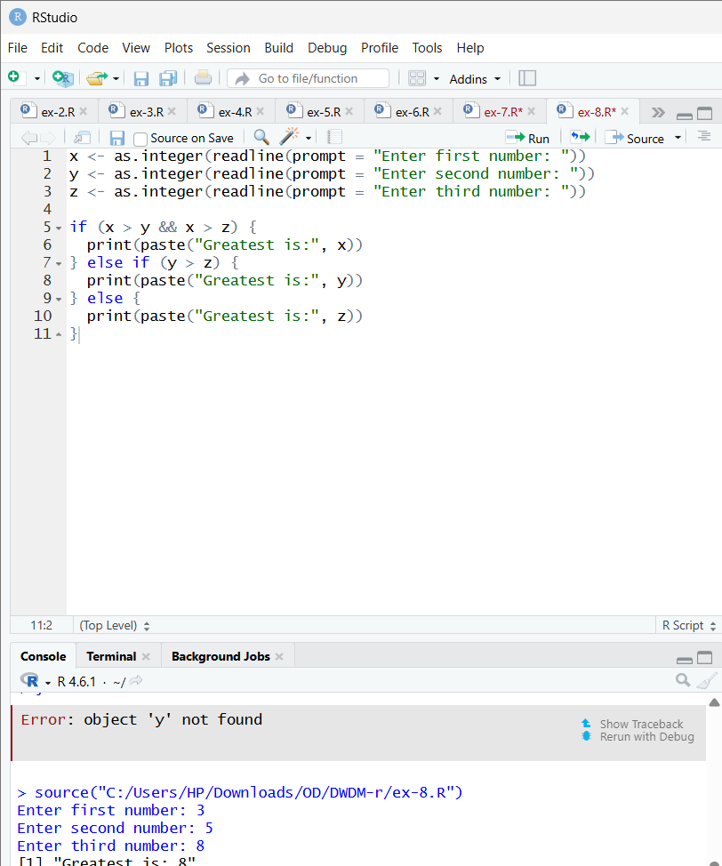
RESULT:
Thus, the greatest among the three numbers was executed successfully.

EXPERIMENT-9
IQR:
AIM:
To write the program for central tendency and data dispersion measures using R tool.
PROGRAM:
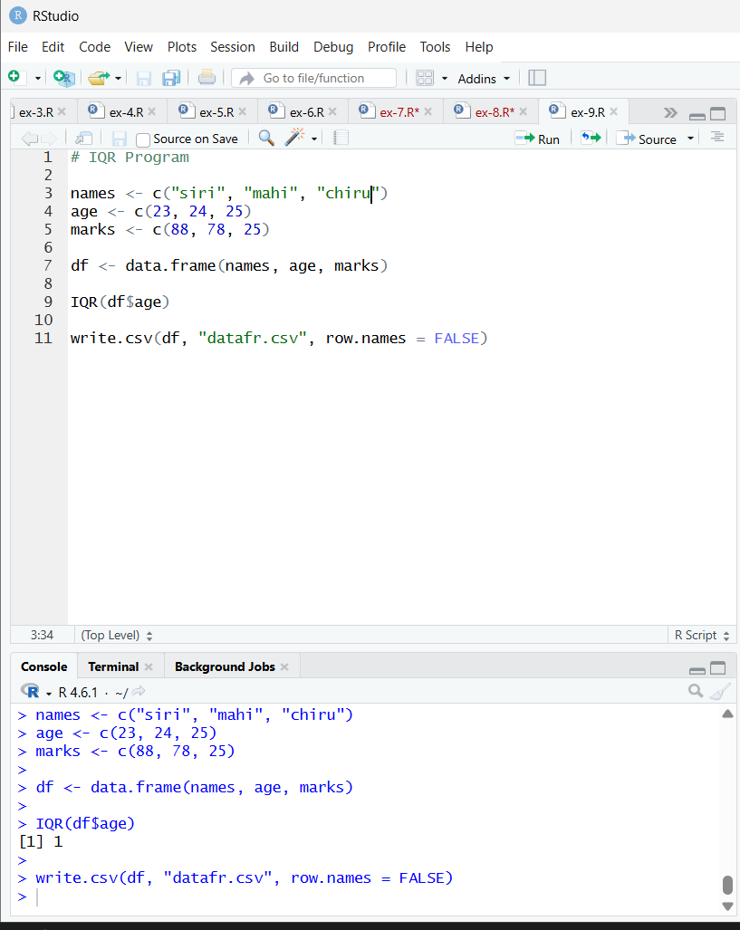
RESULT:
Thus, the program for central tendency and data dispersion measures was executed successfully.

EXPERIMENT-10
QUANTILE:
AIM:
To write the program for central tendency and data dispersion measures.
PROGRAM:
OUTPUT:
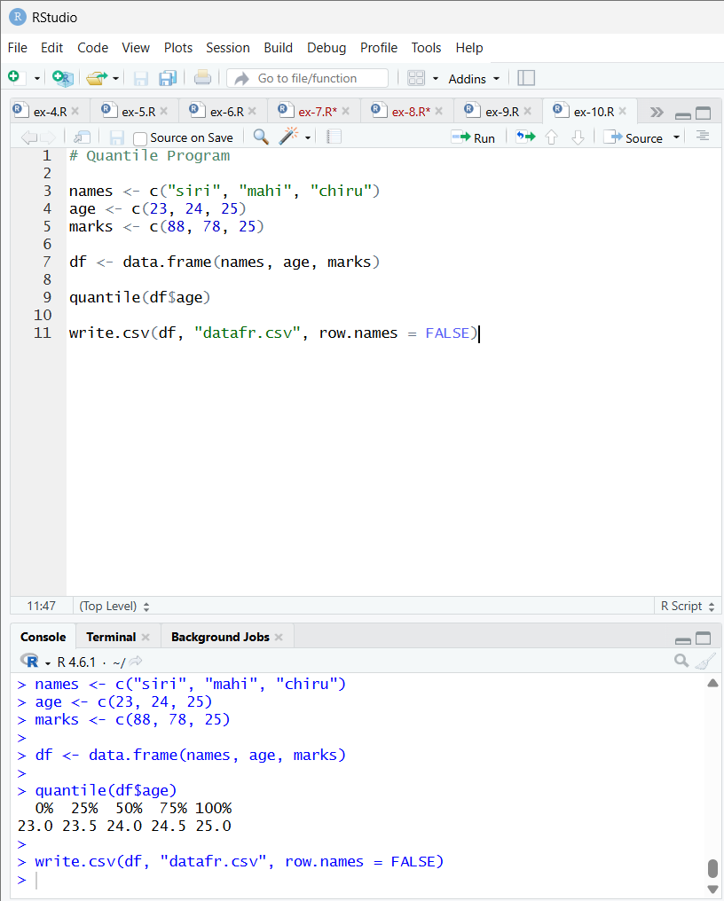
RESULT:
Thus, the program for central tendency and data dispersion measures was executed successfully

EXPERIMENT-11
MID RANGE:
AIM:
To write the program for central tendency and data dispersion measures.
PROGRAM:
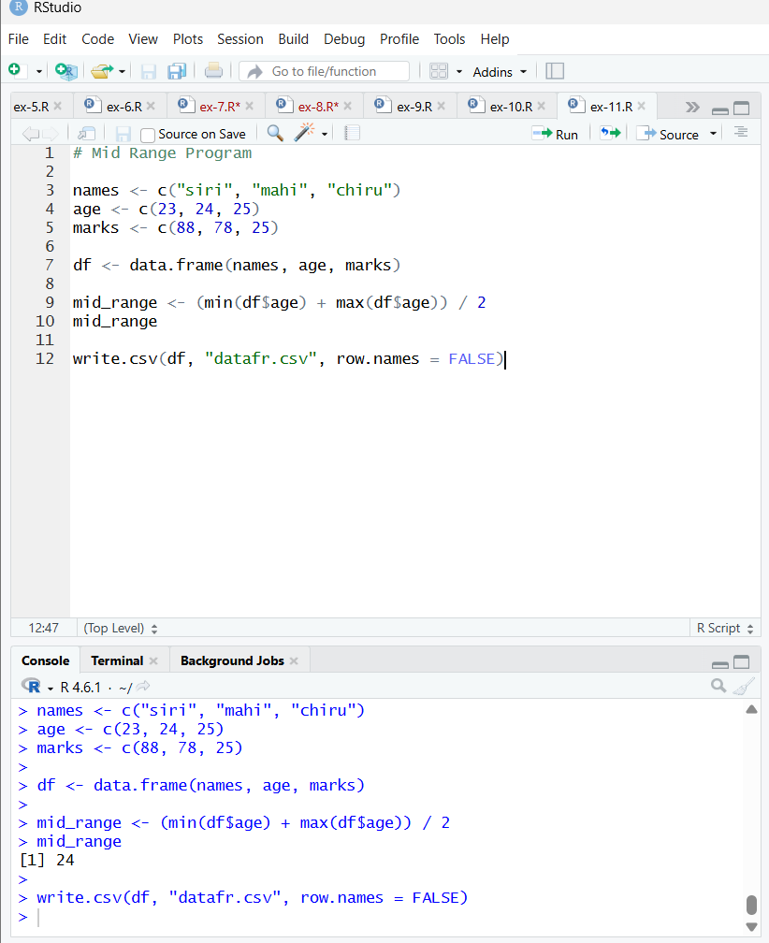
RESULT:
Thus, the program for central tendency and data dispersion measures was executed successfully

EXPERIMENT-12
Z-SCOORE NORMALIZATION:
AIM:
To write the program for Z-scoore normalization using R-tool.
PROGRAM:
OUTPUT:
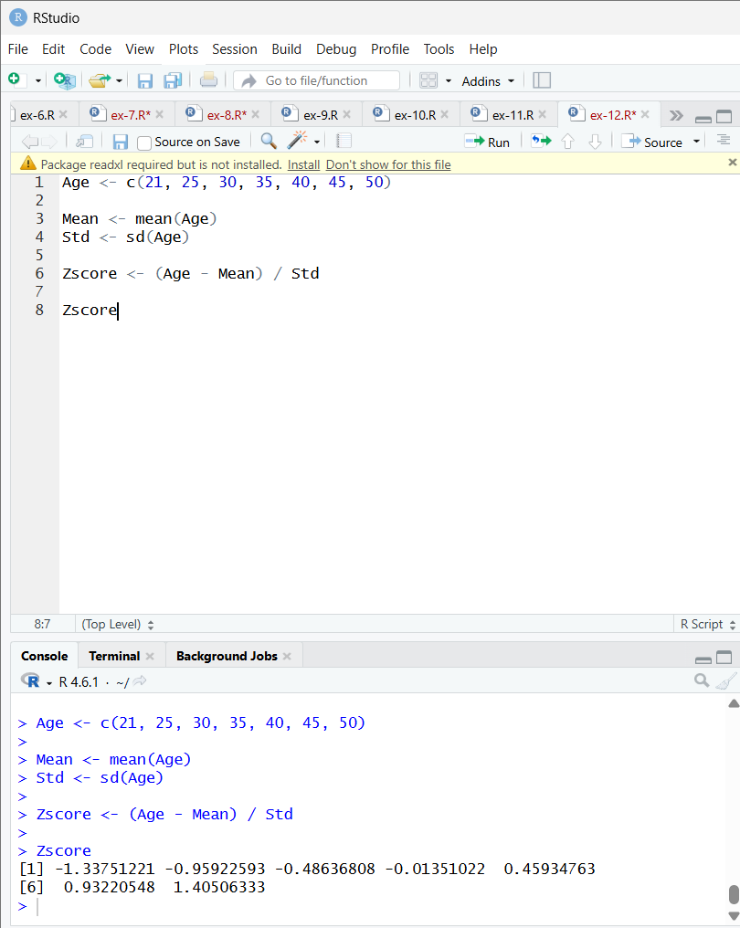

RESULT:
Thus, the Z-score normalization using R tool was executed successfully.

EXPERIMENT-13
MIN,MAX,MEAN,MINMAX:
AIM:

To write the program for the minimum,maximum,mean and minmax using r-TOOL

PROGRAM:
OUTPUT:
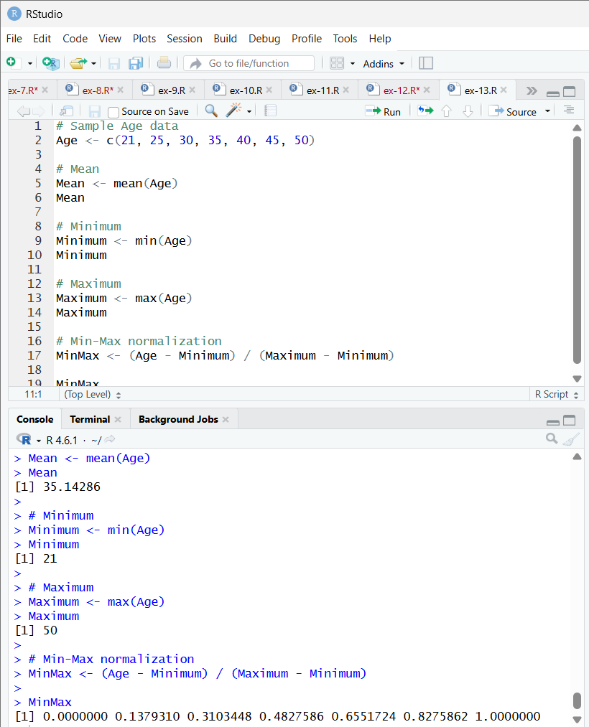

RESULT:
Thus, the program for min,max,minmax,mean was executed successfully.

EXPERIMENT-14
BAR PLOT AND HORIZONTAL BAR:
AIM:
To draw the bar plot and horizontal bar using R-tool.
PROGRAM:
OUTPUT:
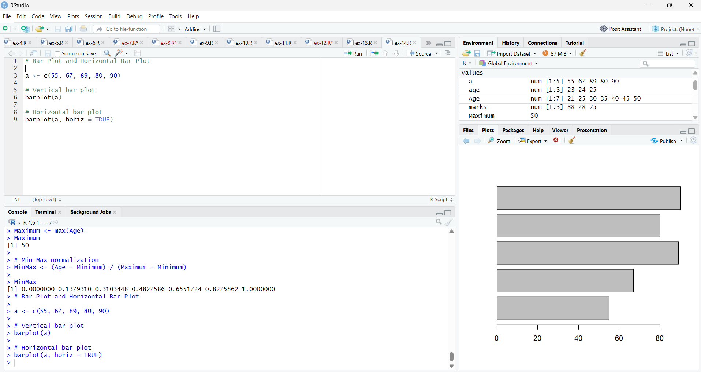
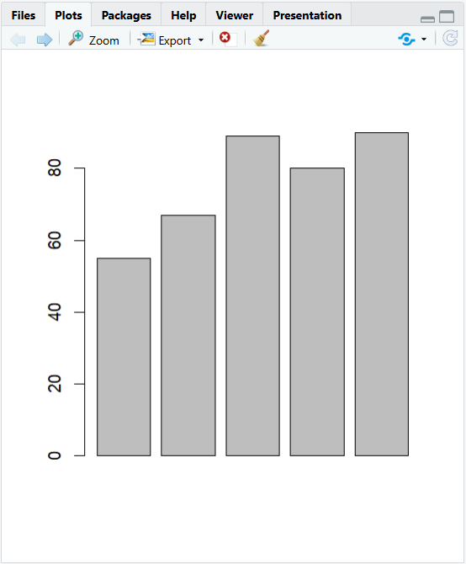
RESULT:
Thus, the bar and horizontal bar plot was executed successfully.

EXPERIMENT-15
BOX PLOT:
AIM:
To draw the box plot using R-tool.
PROGRAM:
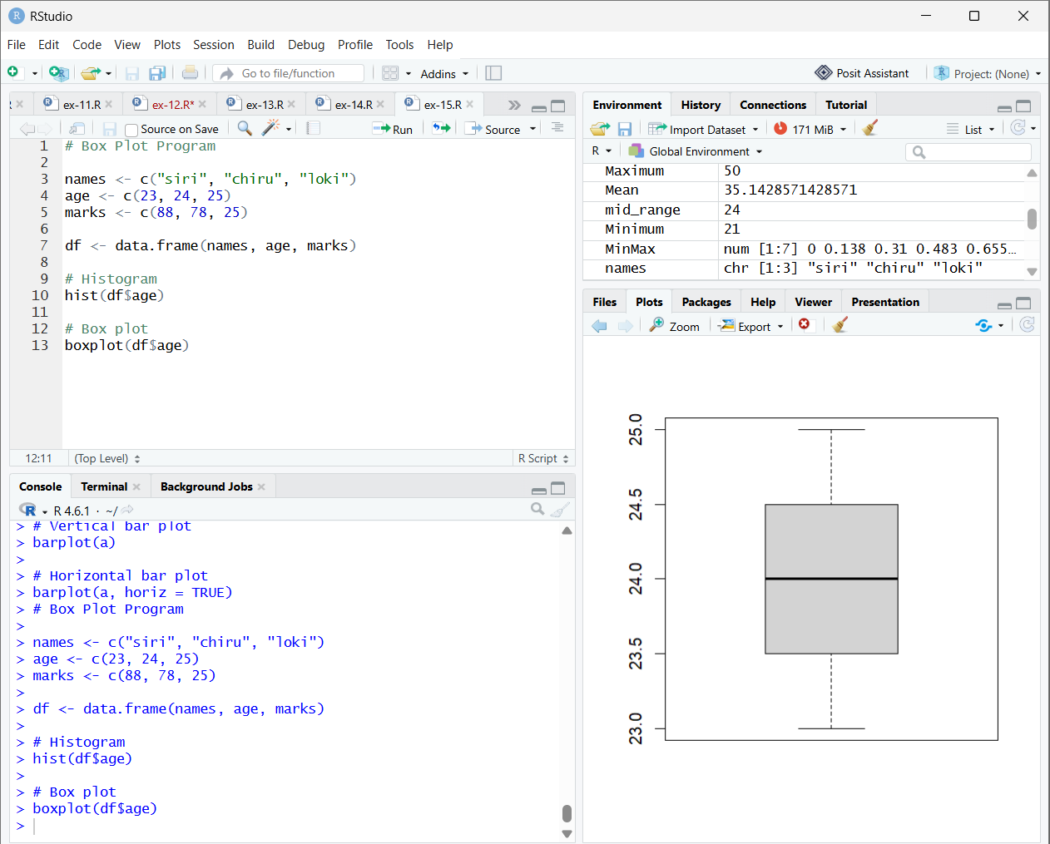
RESULT:
Thus, the box plot was executed successfully.

EXPERIMENT-16
HISTOGRAM:
AIM:
To draw the histogram plot using R-tooll.
PROGRAM:
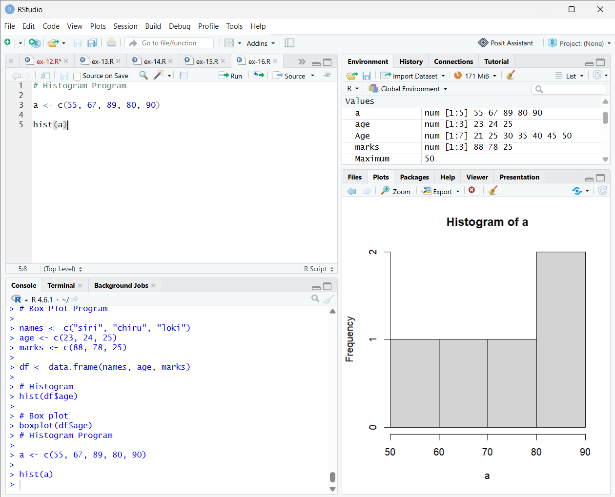

RESULT:
Thus, the histogram plot was executed successfully.

EXPERIMENT-17
CORRELATION ANALYSIS:
AIM:
To write the program for correlation analysis using R-tool.
PROGRAM:
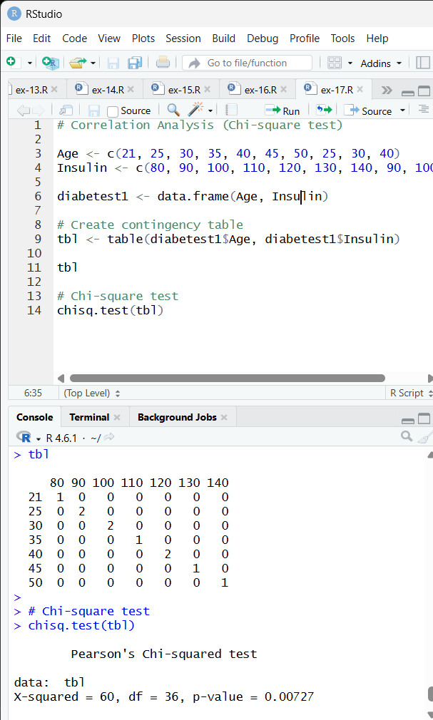
RESULT:
Thus, the correlation analysis was executed successfully.

EXPERIMENT-18
SCATTER PLOT:
AIM:
To draw the scatter plot using R-tool
PROGRAM:
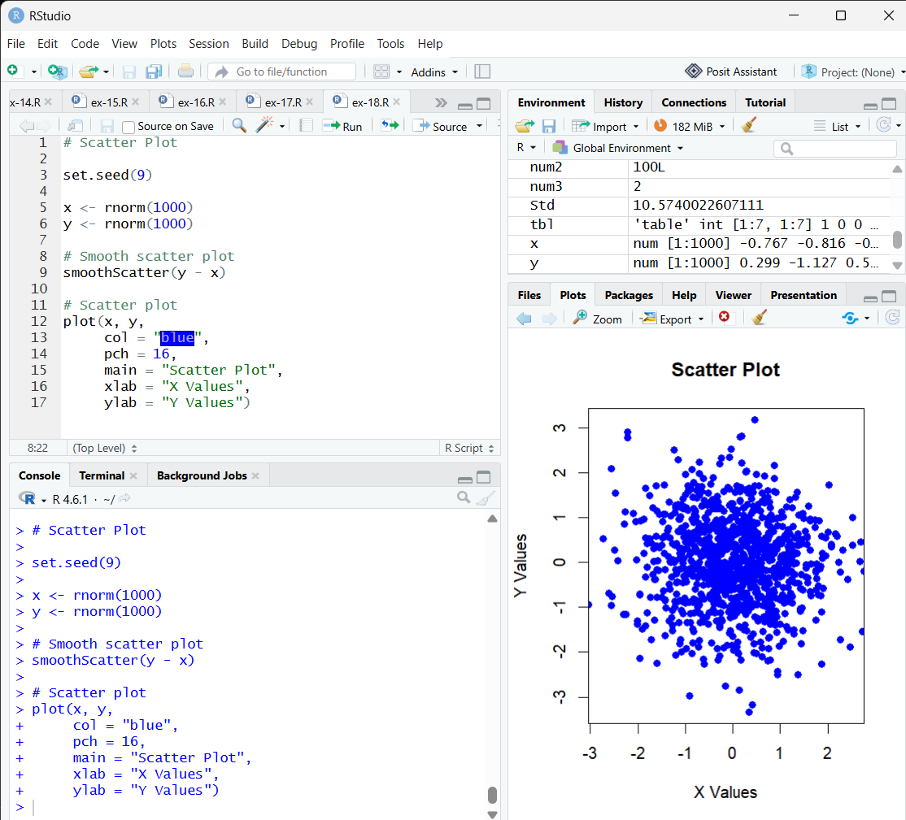

RESULT:
Thus, the scatter plot was executed successfully.

EXPERIMENT-19
LINEAR REGRESSION:
AIM:
To write thr program for the linear regression using R-tool.
PROGRAM:
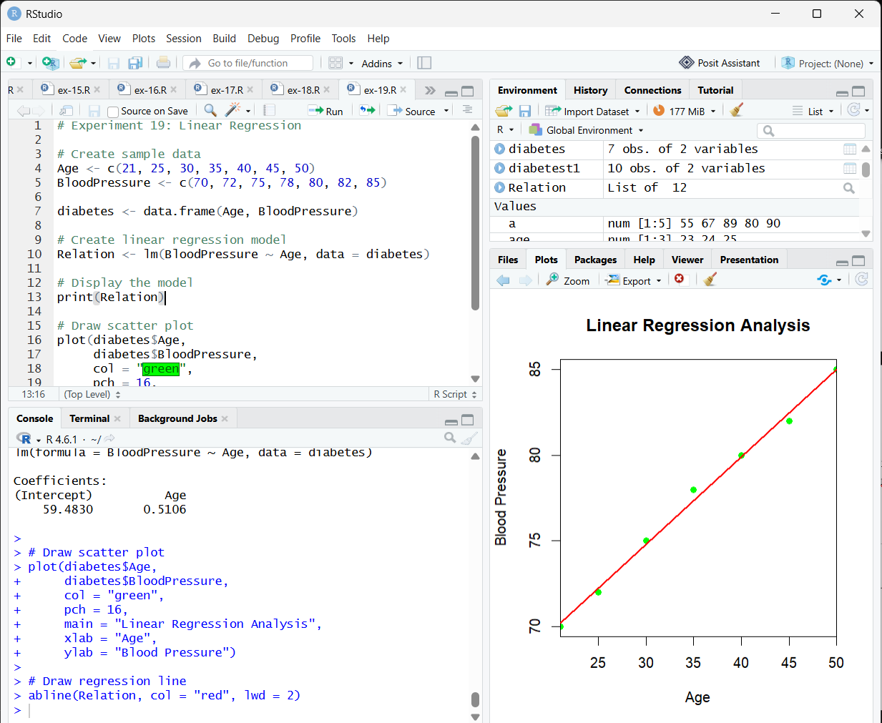
RESULT:
Thus, the linear regression program was executed successfully.

EXPERIMENT-20
MULTIPLE REGRESSION:
AIM:
To write the program for the multiple regression.
PROGRAM:
